BE NIS2 RD Compliance for Log360

**Tagline** – Streamline BE NIS2 RD compliance with automated risk detection and continuous monitoring using Log360.

**Overview**
The BE NIS2 RD Compliance extension for Log360 helps Belgian organizations meet NIS2 Risk Directive requirements. By integrating this extension, IT and security teams gain deep visibility into their risk posture and compliance status.
Log360 continuously collects and correlates log data from Active Directory, Windows, Unix/Linux, Microsoft 365, cloud platforms, and network devices, mapping events directly to NIS2 RD requirements. Security teams can track compliance status in real time, investigate incidents quickly, and generate audit-ready reports with a single click.

**Key Features:**
- Generate comprehensive audit-reports mapped to all BE NIS2 RD risk management requirements and controls.
- Offers pre-built and customizable reports for compliance with interactive dashboards for real-time risk monitoring.
- Includes threat intelligence integration for identifying malicious activity and risk indicators in logs.
- Export reports in PDF and CSV format for auditors, management, or regulatory submissions.
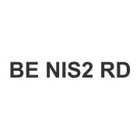
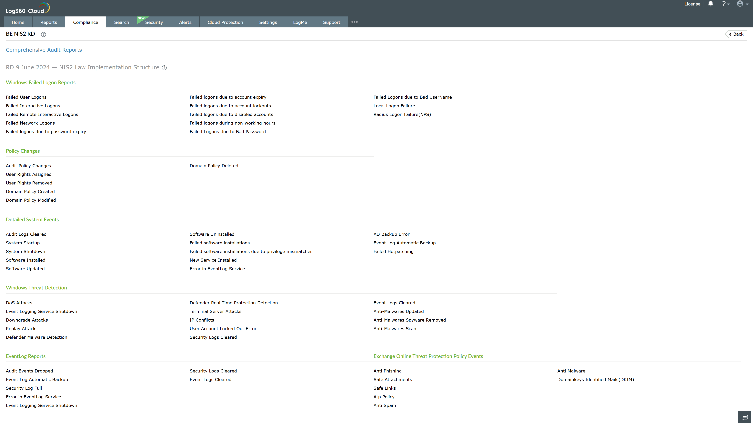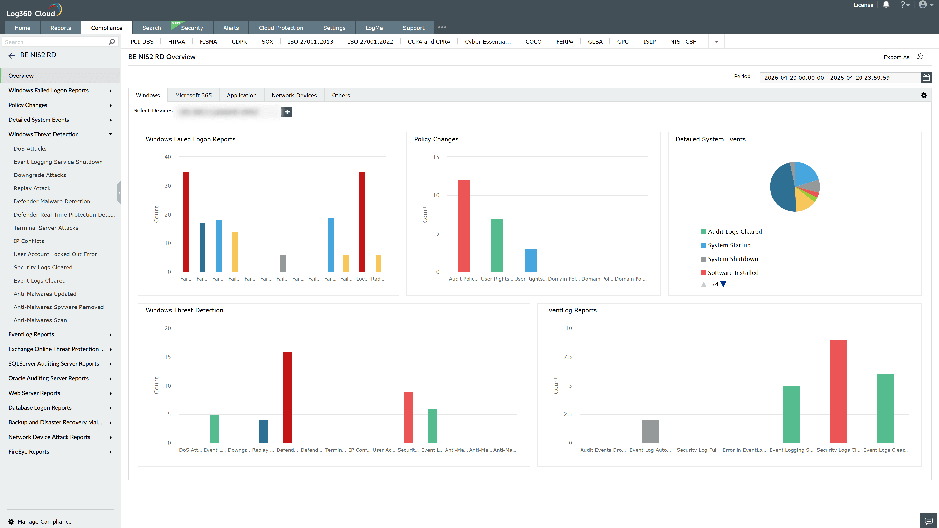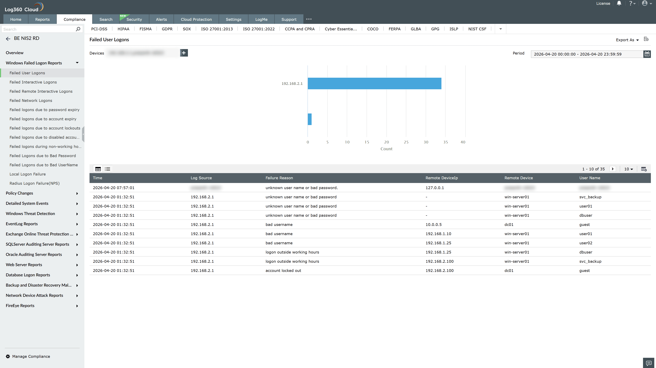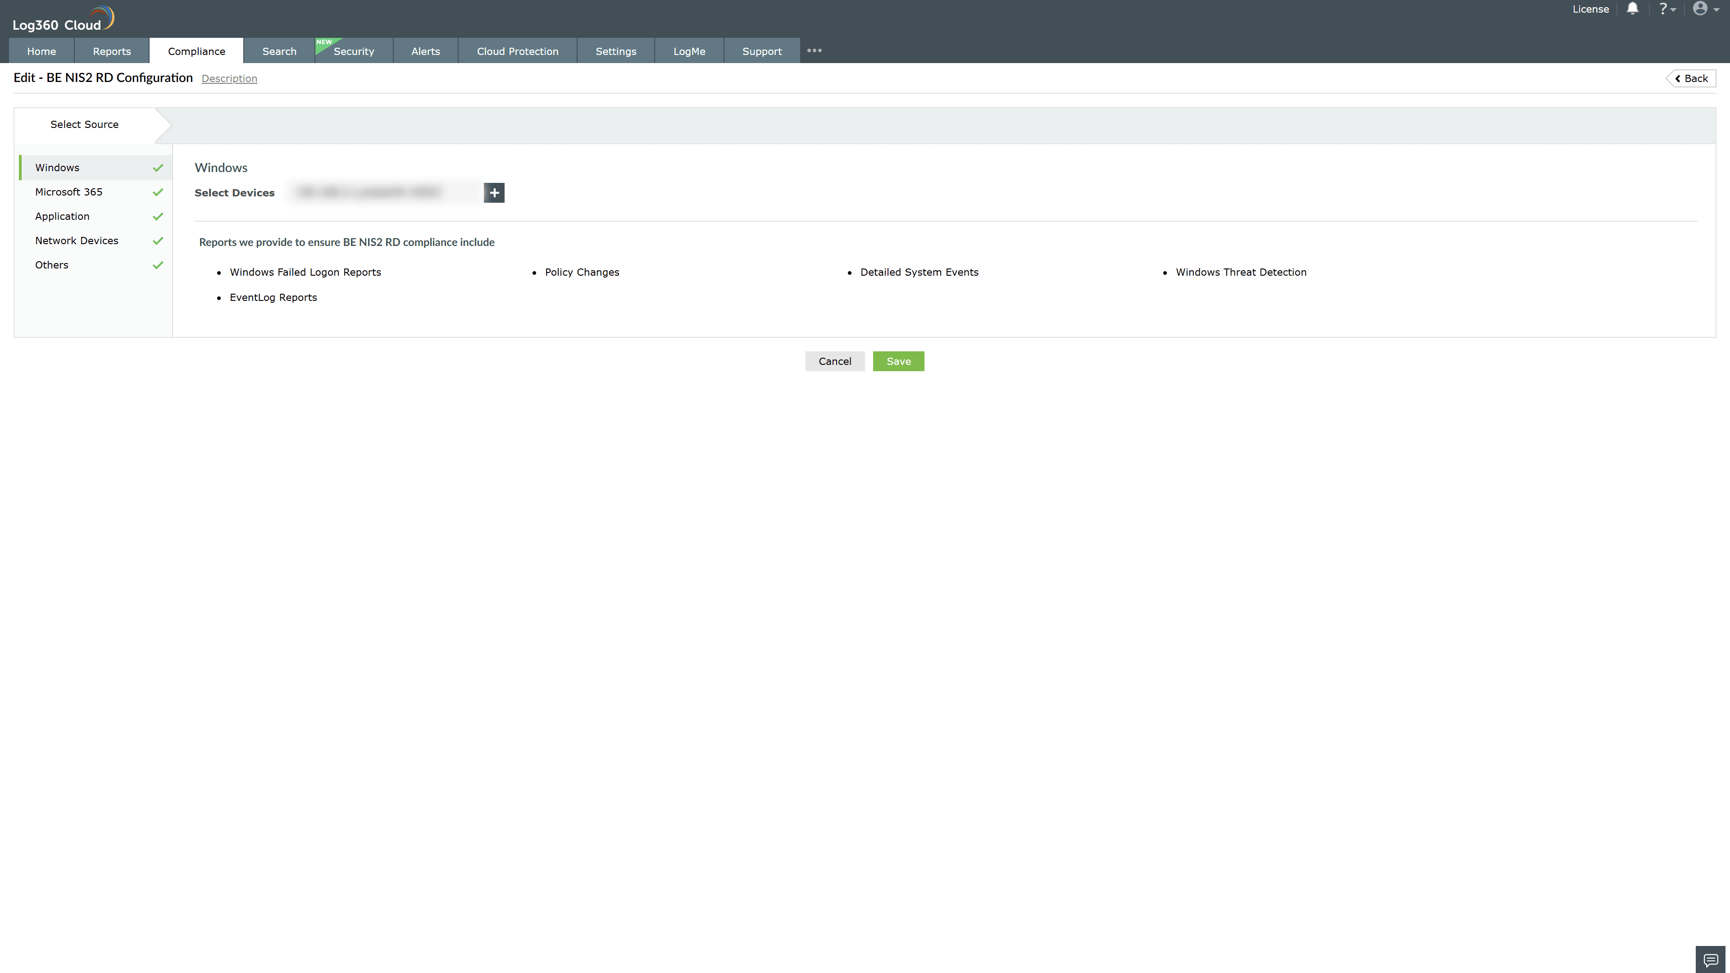
Valid Submission : Yes
Supported Editions : Free, Basic, Standard, Professional, MSSP
Help Document : https://www.manageengine.com/log-management/help/integrations/compliance-extensions.html
Help Video : Not provided
Tags : Log360, Compliance, Privacy monitoring, Data privacy, Regulatory compliance
Supported DCs : US, IN, JP, CA, AU, UK and EU
Privacy Policy:
Terms of Service:
Release Notes:
Predefined reports for the BE NIS2 RD Compliance.

